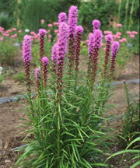 Gayfeather ‘Floristan Purple’: 4’ tall / 20” wide
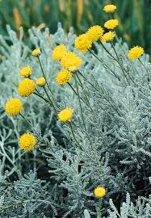 Lavendar Cotton: 1.5’ tall / 3’ wide
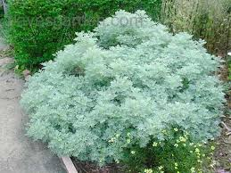 Powis Castle Artemisia: 4’ tall / 6’ wide
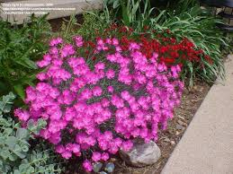Firewitch Cheddar Pink: 1’ tall / 1’ wide
Ice Plant: 6” tall / 2’ wide
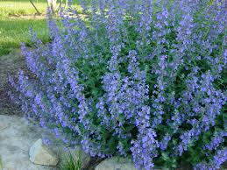Low Cat Mint: 1.4’ tall / 6.3’ wide
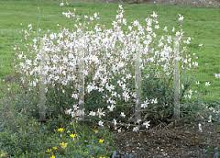White Fountain Gaura: 2’ tall / 3’ wide
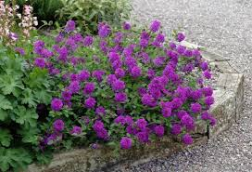 Enduroscape Verbena: 1’ tall / 3’ wide

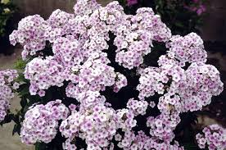John Fanick Perennial Phlox 3’ tall / 3’ wide
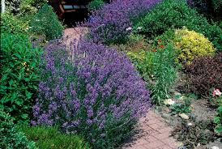Phenomenal Lavendar: 32” tall / 32” wide
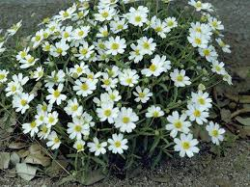Blackfoot Daisy: 6” tall / 2’ wide

