Texas A&M AgriLife Extension





TEXAS PECAN PEST

MANAGEMENT NEWSLETTER

**Bill Ree, Extension Program Specialist III - IPM (Pecan)**

**P.O. Box 2150, Bryan, TX 77806-2150 May 11, 2016**

**Ph: 979-845-6800 #16-5**

**Email:** [**w-ree@tamu.edu**](mailto:w-ree@tamu.edu)

[**http://pecan.ipmPIPE.org**](http://pecan.ipmPIPE.org)

**\*\*\*\*\*\*\*\*\*\*\*\*\*\*\*\*\*\*\*\*\*\*\*\*\*\*\*\*\*\*\*\*\*\*\*\*\*\*\*\*\*\*\*\***

**TEXAS PECAN GROWERS ASSOCIATION**

**4348 Carter Creek, Suite 101 Bryan, TX 77802**

**Ph: 979-846-3285; Fax: 979-846-1752**

**Email:** [**pecans@tpga.org**](mailto:pecans@tpga.org)

[**www.tpga.org**](http://www.tpga.org)

**\*\*\*\*\*\*\*\*\*\*\*\*\*\*\*\*\*\*\*\*\*\*\*\*\*\*\*\*\*\*\*\*\*\*\*\*\*\*\*\*\*\*\*\*\***

**USDA Announces Results of Pecan Marketing Order Referendum**

Date: Friday, May 6, 2016 - 1:00pm

Contact Info: Carl E. Purvis

carl.e.purvis@ams.usda.gov

202 690-0488

Release No.: 093-16

WASHINGTON, May 6, 2016 – The U.S. Department of Agriculture’s (USDA) Agricultural Marketing Service (AMS) is announcing that pecan growers have voted to establish a Federal marketing order for pecans grown in 15 states.

In a referendum conducted March 9 through March 30, 2016, a majority of producers favored implementation of the marketing order. Of those voting, 77 percent of the producers representing 88 percent of the volume supported the marketing order. The marketing order will authorize data collection; research and promotion activities; and regulation of grade, size, quality, pack and containers for pecans grown in Alabama, Arkansas, Arizona, California, Florida, Georgia, Kansas, Louisiana, Missouri, Mississippi, North Carolina, New Mexico, Oklahoma, South Carolina, and Texas.

A council of 17 growers and shellers (handlers) will be nominated by the industry and appointed by the Secretary to administer the marketing order with oversight by AMS. The program will be financed by assessments collected from pecan handlers.

Notice of the referendum was published in the Federal Register on Feb. 29, 2016, and ballots were mailed to all known eligible producers. A final rule implementing the marketing order will be published in a future issue of the Federal Register.

**INSECTS**

**Pecan Nut Casebearer:** PNC is still THE insect of importance right now and producers in the central and northern counties and treating or getting ready to treat. One question in this management operation I’m receiving is what about the rain? My feeling on this is that if the product has had sufficient time to dry, 4 to 6 hours, it should stand up to a light rain, ½ to 1 inch.

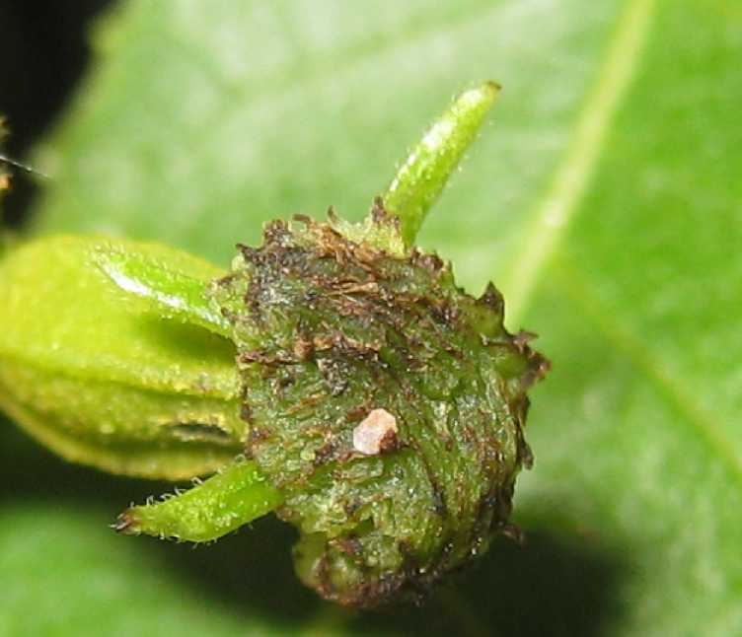

Figure . PNC egg on nutlet

One practice that I do that can help determine if a retreat is needed is that when I am scouting for PNC I will flag clusters with activity. I will note egg color, which nut in the cluster the egg is on, bud feeding or entry and date. This way I can come back to the cluster on a later scouting date to check for any change. I also recommend re-scouting 3 or 4 days after treatment to check for new eggs and check flagged clusters.

For commercial producers, recommended insecticides which can be found in our Extension commercial guide are: Bt,(numerous brand names); methoxyfenozide (Intrepid 2F); spinetoram (Delegate); spinosad (SpinTor, Success and Entrust); tebufnizide (Confirm 2F); chlorantraniliprole (Altacor); mehtoxyfenozide + spinetoram (Intrepid Edge) and flubendimate (Belt). All of these products are cleared for grazing EXCEPT Confirm. Before using any insecticide always consult the label for rates, pests and restrictions.

**Lecanium Scale:**

This spring I have had several calls and emails concerning this very noticeable scale insect. This scale really becomes visible when the insect approaches maturity in the spring. At this time they are usually chestnut brown and are found on the twigs and branches as hemispheres about 1/8 to 1/4 inch in diameter.

Lecanium scale overwinters as an immature scale on branches and twigs of the host plant and matures in early spring. In early to mid-May, the female lays a large number of white to pale yellow eggs beneath her body (under the dome). The eggs hatch into tiny tannish crawlers from mid-May to early June. The crawlers migrate to the undersides of the leaves and feed there until late summer (usually August). Then the tiny insects move back onto the twigs and complete their development the following spring. There is one generation per year.

How did this insect get to my trees? Scales move from host to host in a variety of ways with dispersal probably most often on wind currents or by crawlers hitchhiking on other insects, birds’ feet, or even on a coat sleeve.

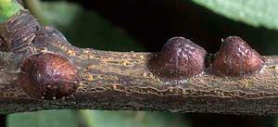

Figure 2. Lecanium scale

Treatment for Lecanium scale is rarely needed in pecans. If a treatment is needed then a broad spectrum insecticide at the time crawlers (immature stage) are observed.

**STATE/REGIONAL MEETINGS, 2016**

**May 12, 2016**

Clay County field day

Contact: Bill Holcombe, CEA-Ag

@ 940-538-5042

[wcholcombe@ag.tamu.edu](mailto:wcholcombe@ag.tamu.edu)

**State Meetings**

**May 17, 2016**

**Noble Foundation**

Advanced Pecan Pest Management Workshop

9 a.m. to noon

Southern Oklahoma Technology Center

Ardmore, Oklahoma

Contact: Maggie Scott @ 580-224-6375

**June 2-4, 2016**

Oklahoma Pecan Growers Conference

Tulsa, OK

Contact: Amanda Early @ [Amanda.early@okstate.edu](mailto:Amanda.early@okstate.edu) or 405-744-8800

**June 16-17, 2016**

TriState Pecan Convention

Best Western Inn & Suites

Alexandria, LA

Contact: Stephen Norman

[pecans@rosaliepecans.com](mailto:pecans@rosaliepecans.com) or 318-448-3139

**July 10-13, 2016**

**TPGA annual conference and trade show**

**San Marcos, TX**

**Contact: TPGA @ 979-846-3285**

**\*\*\*\*\*\*\*\*\*\*\*\*\*\*\*\*\*\*\*\*\*\*\*\*\*\*\*\*\*\*\*\*\*\*\*\*\*\*\*\*\*\*\*\*\***

**The information given herein is for educational purposes only. References to commercial products or trade names are made with the understanding that no endorsement by the Texas A&M AgriLife Extension Service is implied.**

**Educational programs of the Texas A&M AgriLife Extension Service are open to all people without regard to race, color, religion, sex, national origin, age, disability, genetic information or veteran status.**

**The Texas A&M University System, U.S. Department of Agriculture, and the County Commissioners Courts of Texas Cooperating**

.