Texas A&M AgriLife Extension





TEXAS PECAN PEST

MANAGEMENT NEWSLETTER

**Bill Ree, Extension Program Specialist III - IPM (Pecan)**

**P.O. Box 2150, Bryan, TX 77806-2150 July26, 2016**

**Ph: 979-845-6800 #16-9**

**Email:** [**w-ree@tamu.edu**](mailto:w-ree@tamu.edu)

[**http://pecan.ipmPIPE.org**](http://pecan.ipmPIPE.org)

**\*\*\*\*\*\*\*\*\*\*\*\*\*\*\*\*\*\*\*\*\*\*\*\*\*\*\*\*\*\*\*\*\*\*\*\*\*\*\*\***

**TEXAS PECAN GROWERS ASSOCIATION**

**4348 Carter Creek, Suite 101 Bryan, TX 77802**

**Ph: 979-846-3285; Fax: 979-846-1752**

**Email:** [**pecans@tpga.org**](mailto:pecans@tpga.org)

[**www.tpga.org**](http://www.tpga.org)

**\*\*\*\*\*\*\*\*\*\*\*\*\*\*\*\*\*\*\*\*\*\*\*\*\*\*\*\*\*\*\*\*\*\*\*\*\*\*\*\***

**INSECTS**

As the season progresses into the last half of the year there can be several late season pests that need attention, some of these being:

Hickory shuckworm: Treatment time (half shell hardening) for HSW is fast approaching for the early maturing varieties. Unfortunately we do not have a good means to monitor activity and determine population densities as we do with PNC so treatments are based on the fact there was a problem during the previous season and pecans have reached the half shell hardening stage.

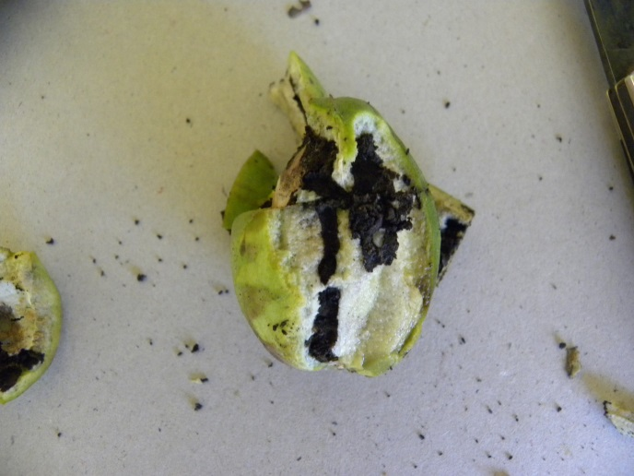

Figure . Typical shuckworm damage

After shell hardening feeding is restricted to the shuck as shown in Figure 1. HSW larvae are a dirty creamy white and larvae do not push frass outside the shuck as does PNC.

**IF** only HSW is being targeted then the “caterpillar” specific products such as Intrepid, Intrepid Edge, Altacor, Confirm, SpinTor and Belt can be used. If other pests need to be controlled such black pecan aphid, stink bugs then a broad spectrum insecticide will be needed. The residual of Bt. based products is too short without making numerous treatments to be effective.

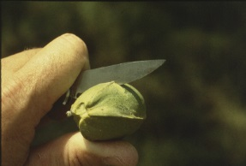

Figure . Checking for shell hardening

The status of shell hardening can be made by making cross sectional cuts with a knife starting at the tip end and gradually working toward the stem end.

Pecan weevil: Treatment time for pecan weevil is when kernel formation of the earliest maturing varieties starts dough formation at the tip of the nut. Early Extension publications had treatment time around August 20th but this was before the release of early maturing varieties. Treatments should be applied regardless of trap catches. The second application will be determined by trap catches. Adult emergence traps are important but really pay for themselves by detecting a late drought delayed emergence. Monitor traps until the last variety has reached shuck split. Where drip irrigation is used on heavy soils you can have a normal emergence and drought delayed emergence under the same tree. Insecticide treatment recommendations include carbaryl (Sevin) and several pyrethroid class materials.

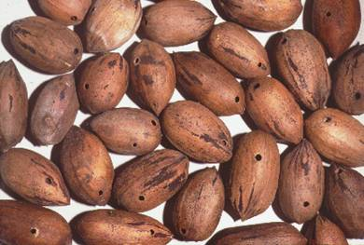

Figure . Typical pecan weevil exit holes

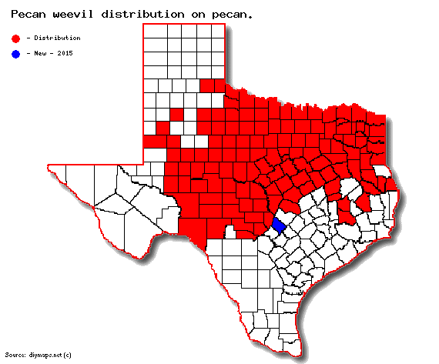

Figure . Known distribution of pecan weevil on pecan in TX. Hayes county in blue is newest detection

Mites: Pecan leaf scorch mites are still an issue and should not be mistaken for the Oligonychus mite*, Oligonychus viridis* which feeds only on the upper surface of leaflets. I have never seen an issue with this mite.

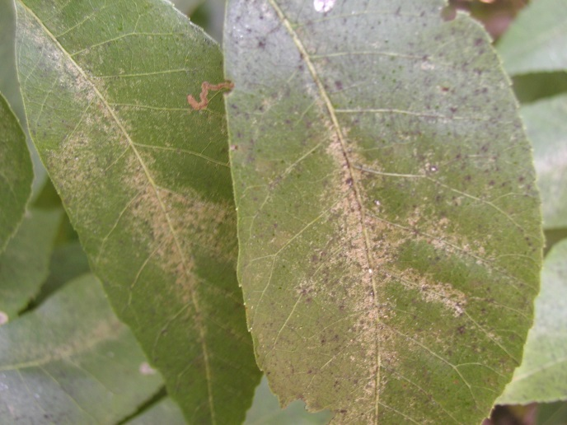

Figure . Oligonychus mite damage.

Stink bugs/Leaffooted Bugs: Both of these two groups of insects can cause kernel spotting and nut drop during the water stage. However, one key difference between these two is that leaffooted bugs will reproduce on pecan while stink bugs use pecan only as an adult feeding host.

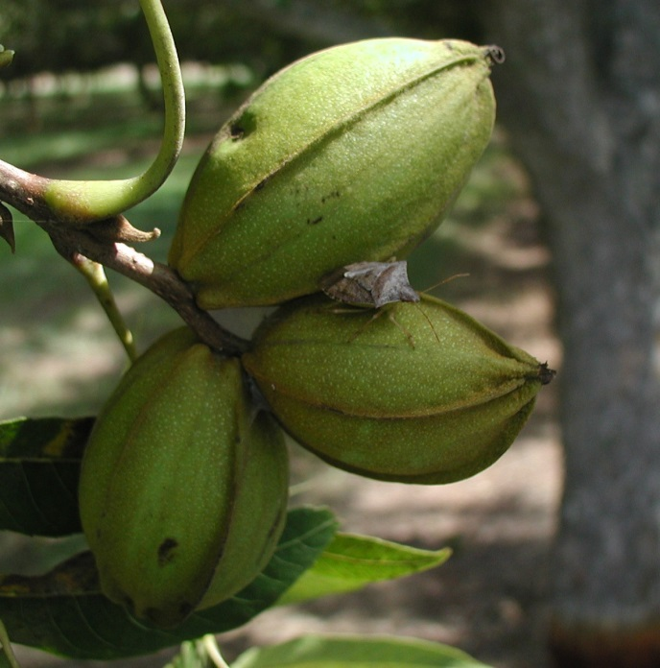

Figure . Brown stink bug feeding on pecan

Management of this group can be challenging and you need to be a detective. Be aware of crops and vegetation around the orchard which could lead to adults moving into the orchard. Are there row crops (soy beans, sorghum, and cotton) that are near harvest of weedy pastures that have been recently shredded? Watch for SB/LFB on clusters on border row trees. There are no thresholds for making treatment decisions but if stink bugs are being found then you have too many and treatment is warranted.

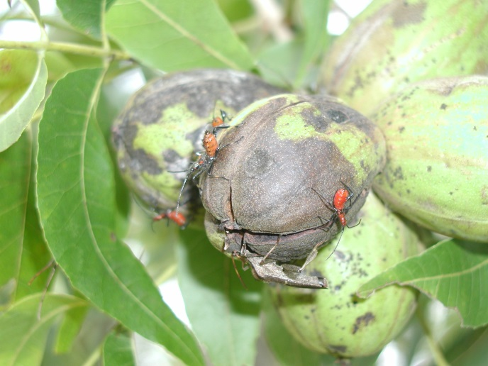

Figure 7. Leaffooted bug nymphs on pecan.

**STATE PECAN SHOW RESULTS**

The 2015 state pecan show was judged during the annual TPGA conference, July 10, 2016 and consisted of 239 entries across 45 variety classes. Congratulations to all that had entries in the show for you had to have had some quality pecans just to get to the show. For a complete list of entries and placers please see the attachment with this letter. The judges for this year’s show include: Larry Stein, Bill Ree, George Ray McEachern, Leo Lombardini, Xinwang Wang, and LJ Grauke.

The following are the champions and reserve champions for the four divisions.

**New and Classic Division**

Champion: Waco; 39.91 nuts/lb.; 57.21 % K

Gary Conner, Jack Co.

Reserve Champions: Barton; 38.53 nuts/lb; 55.02% K; Gary Rainwater; Guadalupe Co.

**Commercial Division**

Champion: Cheyenne; 41.04 nuts/lb.; 58.15% K

Robertson Family Farm, Kimble Co.

Reserve Champion: Hopi; 42.25 nuts/lb.; 60.86 % K ; Steve Stifflemeire, San Saba Co.

**Native Division**:

Champion: 52.08 nuts/lb.; 49.14% K

John Vermersch; Austin Co.

Reserve Champion: 56.31 nuts/lb.; 48.26 %K

Luedeker Farms; Austin Co.

**Lightest Native**

Champion: 736.36 nuts/lb.

Gary Conner; Jack Co.

Reserve Champion: 731.61 nuts/lb.;

Katherine Kniffen; Menard Co.

**STATE/REGIONAL MEETINGS, 2016**

**TX meetings**

**August 11, 2016**

Comanche County

Contact: Mike Berry – CEA Comanche County

[mwberry@ag.tamu.edu](mailto:mwberry@ag.tamu.edu)

325-356-2539

**STATE Meetings**

**August 3, 2016**

California Pecan Growers Meeting

Linwood Nursery

LaGrange, CA

Contact: Mark Hendrixson @

559-859-2712

**August 9, 2016**

Alabama Pecan Growers Summer tour

Information: [www.alabamapecangrowers.com](http://www.alabamapecangrowers.com)

**August 26, 2016**

Arizona Pecan Growers

Clarion Hotel, Tucson, AZ

Contact: Mike Kilby @ 520-403-4613 or

mkilby@cals.ariziona.edu

**September 15, 2016**

Alabama Pecan Growers Annual Conference

Gulf Coast Research and Extension Center

Fairhope, AL

Info: www.alabamapecangrowers.com

**\*\*\*\*\*\*\*\*\*\*\*\*\*\*\*\*\*\*\*\*\*\*\*\*\*\*\*\*\*\*\*\*\*\*\*\*\*\*\*\***

**The information given herein is for educational purposes only. References to commercial products or trade names are made with the understanding that no endorsement by the Texas A&M AgriLife Extension Service is implied.**

**The members of Texas A&M AgriLife will provide equal opportunities in programs and activities, education, and employment to all persons regardless of race, color, sex, religion, national origin, age, disability, genetic information, veteran status, sexual orientation or gender identity and will strive to achieve full and equal employment opportunity throughout Texas A&M AgriLife.**

**The Texas A&M University System, U.S. Department of Agriculture, and the County Commissioners Courts of Texas Cooperating**

**\*\*\*\*\*\*\*\*\*\*\*\*\*\*\*\*\*\*\*\*\*\*\*\*\*\*\*\*\*\*\*\*\*\*\*\*\*\*\*\***

.