Texas A&M AgriLife Extension





TEXAS PECAN PEST

MANAGEMENT NEWSLETTER

**August 15, 2019, No. 19-7**

**Bill Ree, Extension Program Specialist III – IPM**

**Texas A&M AgriLife Extension**

**1470 William D. Fitch Parkway, 2150 TAMU**

**College Station, TX 77843-2150**

**979-458-0335 – office**

**w-ree@tamu.edu**

**\*\*\*\*\*\*\*\*\*\*\*\*\*\*\*\*\*\*\*\*\*\*\*\*\*\*\*\*\*\*\*\*\*\*\*\*\*\*\*\***

**TEXAS PECAN GROWERS ASSOCIATION**

**\*\*\*\*\*\*\*\*\*\*\*\*\*\*\*\*\*\*\*\*\*\*\*\*\*\*\*\*\*\*\*\*\*\*\*\*\*\*\*\***

**TEXAS PECAN GROWERS ASSOCIATION**

**4348 Carter Creek, Suite 101 Bryan, TX 77802**

**Ph: 979-846-3285; Fax: 979-846-1752**

[**pecans@tpga.org**](mailto:pecans@tpga.org)

[**www.tpga.org**](http://www.tpga.org)

[**https://www.facebook.com/PecanSouth**](https://www.facebook.com/PecanSouth)

**https://www.facebook.com/TexasPecanGrowers**

**\*\*\*\*\*\*\*\*\*\*\*\*\*\*\*\*\*\*\*\*\*\*\*\*\*\*\*\*\*\*\*\*\*\*\*\*\*\*\***

**INSECTS**

Pecan Weevil: Pecan weevils begin to emerge from the soil around the first of August so emergence is underway.

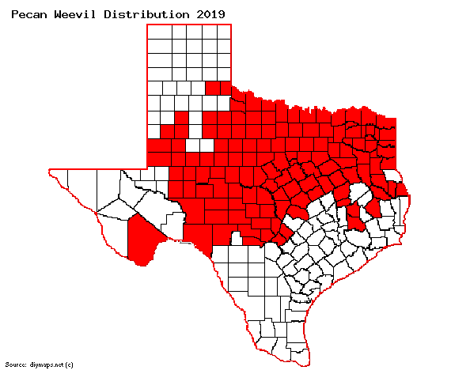

Figure . Most currently known distribution of pecan weevil in Texas

Pecan weevil management is directed at

preventing female weevils from laying eggs in nuts and successful oviposition can not happen until late gel/early dough formation occurs at the tip of the nut. First application of and insecticide should be made when this kernel formation stage has been reached, regardless of any trap catches or lack of. A second application will be needed 10 days later. Any adult emergence traps need to be monitored until the latest maturing cultivar has reached shuck split. Female weevils are not known to oviposit after shuck split. Insecticides recommended for pecan weevil can be found at the end of this letter.

Additional information on pecan weevil can be found in the new AgriLife Extension publication; “ENTO-089: Controlling the Pecan Weevil” which can be obtained through the Texas A&M AgriLife Bookstore: <https://www.agrilifebookstore.org/default.asp>

If your orchard is in a county that is not shown in the map and if you find an infestation please report the infestation to your local county Extension agent.

Stink Bugs: This is the time of year when adult stink bugs and leaffooted bugs can start moving into orchards. During this time of year when other host plants are drying up and some row crops such as grain sorghum are being harvested, this will cause adults to move so check border rows for adults on clusters. We do not have thresholds for stink bug/leaffooted bugs but if they can be found on clusters, that is too many. Insecticides for this group can be found at the end of this letter.

Black Pecan Aphid: I observed several isolated colonies of black aphids on my Kanza trees yesterday near Caldwell, TX. Check the interior portion of the canopy for the characteristic yellow rectangular areas on the leaflets AND the presence of aphids. Often times spot treatments can be made for this insect if populations are localized.

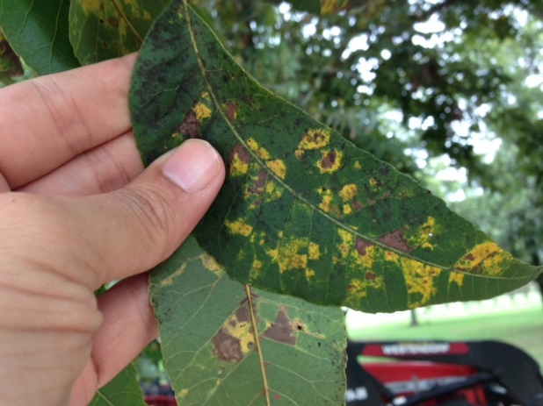

Figure . Black pecan aphid damage

Walnut Caterpillar: The next generation walnut caterpillar should be active at this time.

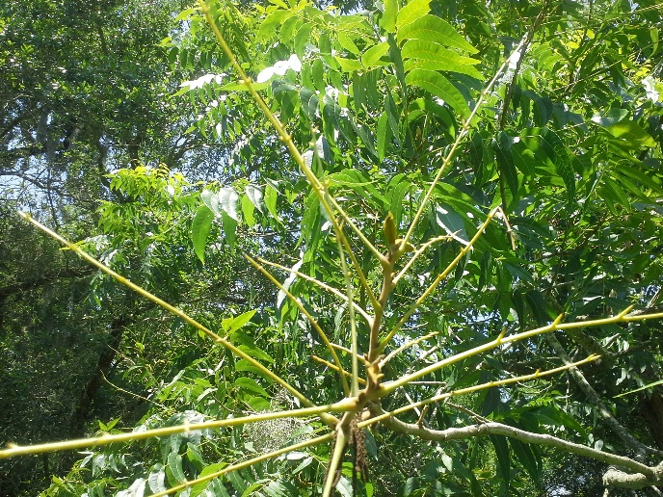

Figure . Pecan terminal defoliated by walnut caterpillar

One sign of ongoing activity will be defoliated terminals as shown in Figure 3. If defoliation is observed, check the tree for active colony and treat as needed. The vast majority of the defoliation is done when the larvae reach the 5th instar where the caterpillars are now black with white hairs. Research has shown that approximately 80% of all the foliage consumed by the walnut caterpillar will occur over 3 -5 days once the 5th instar is reached.

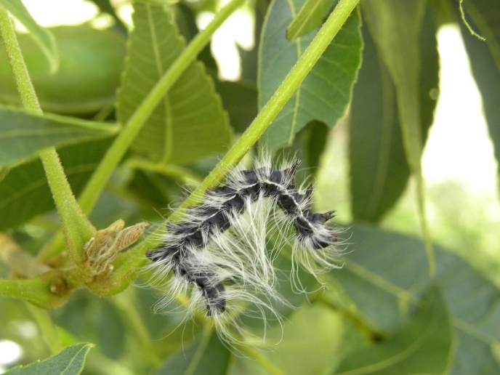

Figure . 5th instar walnut caterpillar.

**Stored Product Insects**

As we approach the harvest season, for those producers that have retail stores I encourage the use of pheromone traps to monitor and detect the presence of stored produce insects. There are pheromone traps available for many of the “stored product pests”. These traps are an alarm system that the insect(s) are present and not a control method. Insects such as Indian meal moth and drugstore beetle can cause issues and early detection is important. As an example, traps for the Indian meal moth as shown in figure 2 can be hung in store rooms while the dome trap for various beetles can be placed under counters where they are out of site.

The key to stored product insect management is early detection and sanitation.

There are several sources of stored product insect traps and pheromone. Two companies that I am familiar with are:

<https://trece.com/>

<https://www.alphascents.com/>

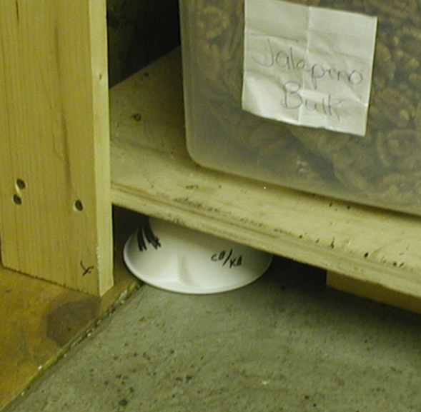

Figure . Dome trap for various stored product beetles

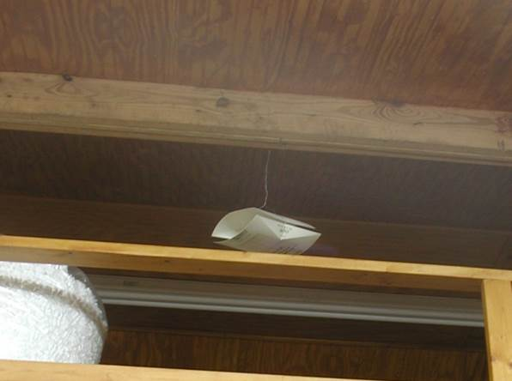

Figure . Trap for Indian meal moth in store room

**STATE/REGIONAL MEETINGS**

**September 5-6, 2019**

Arizona Pecan Growers Conference

Desert Diamond Casino and Hotel

Tucson, AZ

Contact: Mike Kilby @

mkilby@email.arizona.edu

**\*\*\*\*\*\*\*\*\*\*\*\*\*\*\*\*\*\*\*\*\*\*\*\*\*\*\*\*\*\*\*\*\*\*\*\***

**The information given herein is for educational purposes only. References to commercial products or trade names are made with the understanding that no endorsement by the Texas A&M AgriLife Extension Service is implied.** **The members of Texas A&M AgriLife will provide equal opportunities in programs and activities, education, and employment to all persons regardless of race, color, sex, religion, national origin, age, disability, genetic information, veteran status, sexual orientation or gender identity and will strive to achieve full and equal employment opportunity throughout Texas A&M AgriLife. The Texas A&M University System, U.S. Department of Agriculture, and the County Commissioners Courts of Texas Cooperating**



